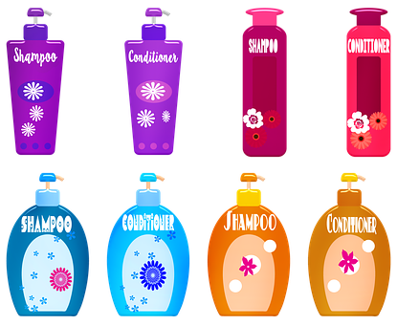

**Choose the right shampoo - Nexxus Aloe Rid Shampoo**

A beautiful and neat hair depends mainly on the product we take from the pharmacy shelf, but not only. Although we are often tempted to opt for 2-in-1 care products - also containing shampoo and conditioner - adapted to the hair type, specialists explain why this choice is unspoiled.

Although often we are tempted to opt for a 2 in 1 - and shampoo and conditioner - adapted to the type of hair. This choice is uninspired. Combined shampoos are not the first option. Combined shampoos that have more than one action, just the simple degreasing being considered insufficient, are not the first option. I'm not my first choice, thinking that if you put and balm, any balm means fat, which for a person with greasy hair and a tendency to a more irritating scalp leads to problems.

Secondly, you do not get such a good volume because the hair will stick to your head and then you have to put extra chemicals that electrize it a bit, blow it up, and grow the list of ingredients. Moreover, for people with higher sensitivity, this can become a problem.

**Cleanse your skin**

Under these conditions, cleansing is no longer right. The best option is for each of us to use pure shampoo like the one you can find on <http://www.nexxusaloeridshampoo.com/> and those who need a balm to use balm, mask, hair creams separately after they have been shampooed and have rinse abundantly. Moreover, if we have problems like dandruff or allergies, it's good to use the conditioner no longer on the tips, on the stem, not on the skin of the head.



**The Founder**

Mr Mohd Ahfaz founder of servicesender.in

Even more for those who claim hair loss or hair loss, these inbuilt fat shampoos are a nasty variant, even if it says the shampoo will also delay hair loss, the doctor warns. That is, prescribing a substance that will cause vasodilation along with fat will spoil all the regenerative power of the active material.

So virtually any shampoo is a detergent. In these detergents there is perfume, there is conditioning that does not spoil - the so-called condoms - and some substances are added. For those who have greasy hair, for example, a larger amount of detergent is put, and for those who have dry hair, there are also moisturizing agents. Besides, shampoos for seborrheic dermatitis, for dandruff, also have active principles.

There are several active principles: some are tars, some are with disinfectants, pyritinol, zinc, for example, which is a general disinfectant, some contain antimycotic, sulfur or selenium bisulphides - which are most active on dandruff and seborrheic dermatitis.

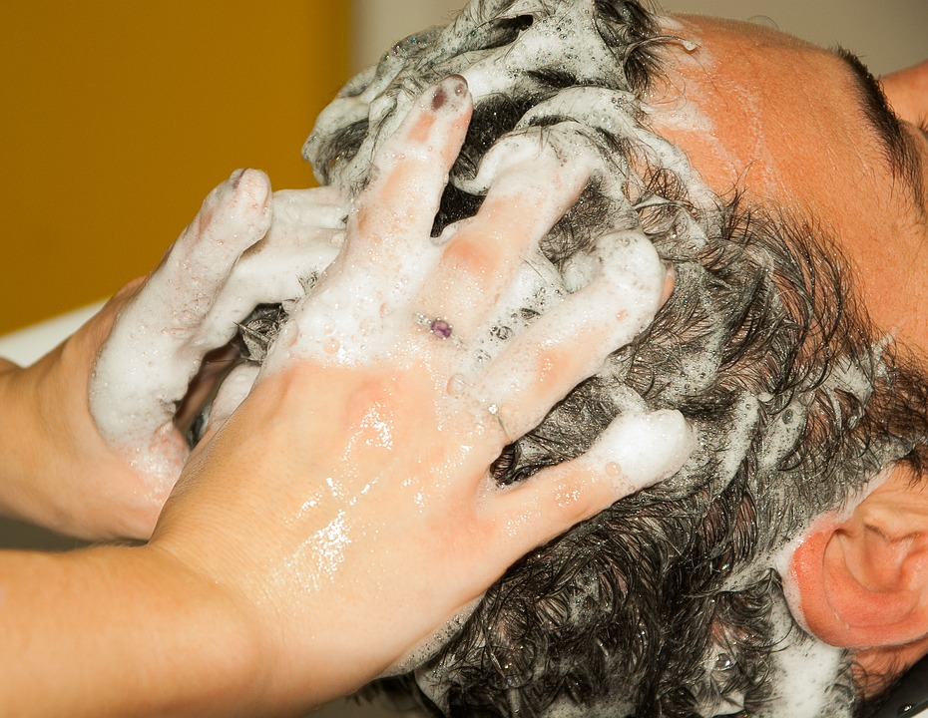

**Shampoo for kids**

When it comes to children, the shampoo should be for them because it has a much lower concentration of detergent in it, and if we have a medical problem - that our hair falls, that we have seborrheic dermatitis, indifferent of the dandruff form, we can buy an antimatter shampoo.

If we have dandruff and take shampoo that does not work. What do we do by eliminating them? There are no universal tests or prescriptions. Some patients have oily dandruff and who go very well - the peak - to the dry hair antimatter shampoo, because in fact, the shell that we see on the shoulders has a different thickness, depending on the area in which the sebaceous gland becomes clogged.

The more it becomes thicker, the thicker the shell is, and if we try to break it, we will bleed, and we will be very hard.

When it's okay, you do not even realize you have dandruff; you see that you're full of white powders like a powder. That's dry or thin hair. It means the gland sinks very high. Moreover, so it does not hurt you so much or crack. Check [this](https://www.healthline.com/nutrition/ways-to-treat-dandruff) out.

Moreover, all these shampoos rotate. Because every category I've been telling you is going on another mechanism. So tars go on inhibiting keratin production - they are the most medical, the most powerful, but the toughest. I start with them because they have maximum efficiency, but not because they are the most peaceful. You do not risk falling your hair, but you risk hurting yourself and becoming too aggressive for you. Moreover, do not know what was first: the egg or the hen, it makes it easier for you to scratch your head or because you washed it with something inappropriate.